
Component Model
Transform diode laser target point into Point Cloud line object
Robotic Cognition System for Wheelchair
Unicamp

Table of Contents
1 Purpose of this Document 3
2 Component Design 4
2.1 Purpose 4
2.2 System Diagram 4
2.3 Component Input 4
2.4 Component Output 4
2.5 Component Processing 4
3 Component Execution 6
4 References 8

Document Information
Project Name: | Robotic Cognition System for Wheelchair
Prepared By: | Tarcísio Franco de Carvalho | Document Version No: | 1.0
Title: | Component Model – Move to the target | Document Version Date: | 05/Jan/2021
Reviewed By: |  | Review Date:
Distribution List
From | Date | Email
Eric Rhomer |  | rohmer@unicamp.br

Acronyms
Acronym | Description
ROS | Robot Operational System
PCL | Point Cloud Library

Document Version History
Version  Number | Version  Date | Revised By | Description | Filename

Purpose of this Document
Define how the related component works and its relation in the main system.

Component Design

Purpose
This component is responsible to request the wheelchair robot to move to a desired target point using path planning, avoiding collisions with objects.

System Diagram

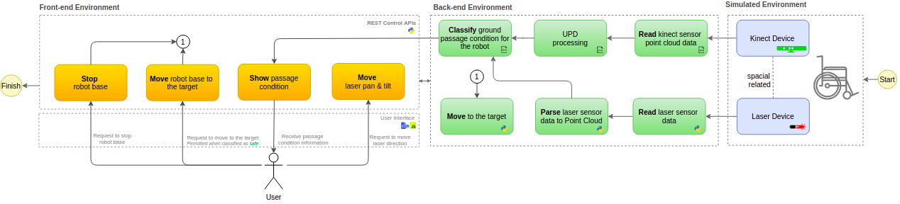

Component Input
This component expects the following input data:
- Origin point x
- Origin point y
- Origin point z
- Target point x
- Target point y
- Target point z

Component Output
This component will draw a point cloud line object based on a origin and target point in y and x

Component Processing
This component has relationship with the move_base/goal ROS node that is part of ROS navigation stack. The diagram below shows this relationship:

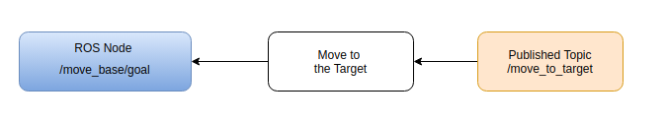

Below the main process flow for this component that runs in cycles:

- Convert the laser orientation data to X and Y axis point direction
- Set X and Y meters ahead to /move_base/goal node
- Monitor requested action completion and return it’s status

References

- Transform
  - Draw 2D point cloud objects: https://pointclouds.org/documentation/classpcl_1_1visualization_1_1_p_c_l_painter2_d.html#details
  - Point Cloud Visualization: https://www.programmersought.com/article/51154789028/
  - PCL Painter 2D: https://gitlab.safeai.ai/serge/pcl/-/blob/pcl-1.7.2rc1/visualization/src/pcl_painter2D.cpp
  - Point Cloud Line Option:
    - https://stackoverflow.com/questions/14797673/find-points-on-the-line-in-point-cloud
    - https://github.com/jimjibone/robotarm/blob/master/Kinect%20Object%20Detector/Object%20Detection/JRConvexHull/JRConvexHull.cpp#L43
  - RANSAC
    - https://pointclouds.org/documentation/tutorials/random_sample_consensus.html
    - https://medium.com/@ajithraj_gangadharan/3d-ransac-algorithm-for-lidar-pcd-segmentation-315d2a51351
    - https://stackoverflow.com/questions/38754668/plane-fitting-in-a-3d-point-cloud
  - Math
    - https://www.geeksforgeeks.org/program-find-line-passing-2-points/
    - https://www.youtube.com/watch?v=JlRagTNGBF0

- Book - Learning Robotics using Python – Second Edition – By Lentin Joseph

